**Homework #11**

GK March 2023

**Instructions:**

Your answers should be *direct and explained*. Show your calculations, formulas, logic you follow etc. Explanations do not have to be verbose; they should be just enough for the instructor and/or TA to understand what you are doing. 80% of the grade goes to the explanations and logic you follow and 20% goes to the result. *Correct result with no explanations gets zero points*.

Please respond with your own words and own understanding. Copying the answers without understanding them, defeats the purpose of this homework -- it violates the code of ethics and the integrity of the course.

* *If you are* ***suspected*** *of copying any part of your answers either from a classmate or a web site (without a reference link), you get a zero to the entire homework.*
* *If it is* ***proven*** *that you have copied or plagiarized, you will be reported to your advisor, your sponsor, and the School; serious consequences to your academic record and/or your student status should follow.*
* *This is applicable to both the giving student and the recipient student*.

For the problems/exercises, it is expected to use a spreadsheet (Excel) and/or your own drawing tool (PowerPoint, Visio, Drawsoft, etc) or make a neat drawing by hand. ***You must embed*** these assets into your WORD file with no external references, specifically for Excel. Unless the TA or I click-and-open the object to see your calculations, you will be missing points. *If you do not know how to do so, ask your colleagues, post the question to the Discussion Homework Area, ask our TA and/or ask me.*

DO NOT REMOVE THIS PAGE FROM YOUR SUBMISSION. Also, answer the questions below:

*How long did it take you to complete this homework? _________4*

*______ hours*

*How many hours did you work on your project this week? ______1_____ hours*

Table of Contents

1. CONSTR, 7pts 2

2. PIOTR, 22pts 2

3. XYZ, 20pts 3

4. EVDEF, 8pts 3

5. GRADES, 18pts 3

6. A2E, 25pts 4

## CONSTR, 7pts

A consulting project has an actual cost in month 10 of $23,000, a scheduled cost of $17,000, and a value completed of $20,000. Find the schedule and cost variances and the three indexes. For each indicate if favorable or unfavorable.

**Answer:**

## PIOTR, 22pts

Consider the following PIOTR project and respective Gantt Chart.

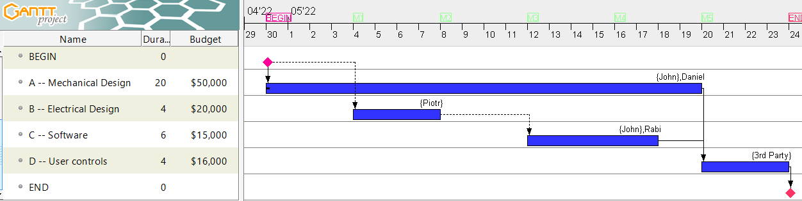

The chart shows four tasks (A, B, C, D), their dependencies, their durations, and their respective budgets.

The numbers shown above are weeks (not days as labeled incorrectly). For example, Task A has a duration of 20-weeks, and the total cost of this task is $50,000. Assume also that the budget per task (aka planned value of the task) is proportional to the duration of the task.

1. (7pts) Compute the PROJECT BUDGET, aka PV at the {EoW#4, EoW#8, EoW#16, EoW#24}. *Show your numerical answer.*
2. (5pts) Compute the Earned Value at the {EoW#4, EoW#8, EoW#16, EoW#24}, ***following the 0-100 rules.*** *Show your numerical answer.*
3. (10pts) Assume that the project was completed perfectly on-time. Compute the Earned Value at the {BoW#5, BoW#9, BoW#17 and EoW#24}, ***following the 50-50 rules.*** *Show your numerical answer.*

*Attach your spreadsheet with the above calculations. It MUST show clearly the answers of (a), (b) and (c) You will not get any credit for this problem otherwise.*

**Answer**:  


## **XYZ, 20pts**

Today is the mid-point in time working on project XYZ. The overall project cost was planned to be $10,000.

Accounting informs us that today’s cost is $6,000 which is overbudget from what you were planning.

You evaluated the progress using the 50-50 rule and you estimated that you accomplished 60% of the overall project work.

1. (5 pts) Draw a sketch showing the PV, AC and EV straight lines – as we did in the class. *OK to be done “by hand”*
2. (5 pts) Would the project be completed earlier or later than expected? If the original plan was 100-days, by how many days earlier or later?
3. (2 pts) What would be the project cost at the completion date?
4. (2 pts) Compute the cost variance from the plan. Are expenses favorable or unfavorable?
5. (2 pts) Compute SPI and CPI. Is the Project X progressing well or not? Why?
6. (4pts) For the above, you assumed that TC=100days. Assume that this is not given to you. Which of the above answers will have to be modified?

*You must show your calculations in this WORD file.*

**Answer:**

a)

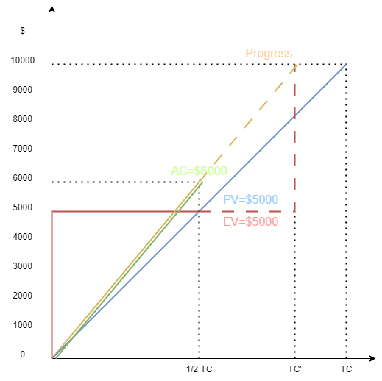

b)

earlier

16.7 days earlier

c)

Actual cost has the same slope as progress, therefore the total cost will be $10000.

d)

Unfavorable, can not profit.

e)

It is progressing well as SPI is equal to 100%.

f)

Answer in part b. It should be days earlier.

## EVDEF, 8pts

Describe 4-different ways that earned value can be determined.

**Answer:**

1) given BAC, EAC, e

2) given AC, EAC, e

3) given AC, BAC, e

4) given AC, BAC, EAC

## **GRADES, 18pts**

Your Term Project Report included three milestones Draft#1, #2 and #3 and the final submission, i.e. four deliveries. The course duration was 13-weeks.

* Draft#1 was due at the end of the 2nd week (EoW#2)
* Draft#2 was due at the end of the 5th week
* Draft#3 was due at the end of the 8th week
* and the final was due at the end of the 11th week

Each draft and the final were supposed to include:

* Draft#1: 3-sections
* Draft#2: 5 additional sections
* Draft#3: 4 additional sections
* Final: 6 additional sections

Completing all sections at the 11th week earns you 100 as the project grade. Completing fewer reduces the grade proportionally.

You submitted Draft#1 on-time, but with only 2 of the expected sections

You submitted Draft#2 also on-time, adding 3-sections

***Today is the end of 8th week*** and you just submitted Draft#3, with 5-sections more. (As of today, you submitted 2+3+5=10 sections.)

* **What would be your numerical grade (i.e. units out 100) based on your FINAL submission at the deadline EoW#11?**
* **The professor asked you: how much more time would need to complete all sections? What would you answer?**

Follow the steps below to answer the above questions. Include your solution in your WORD file.

1. Draw the PV of the project using an Excel graph.
2. (4pt) Draw the EV (assuming the 100% rule) of the project overlaying it in the same graph
   * *Snap a picture of the graph including (a) and (b) and attach it.*
3. (8pt) Apply a trend line on the EV using 2nd order polynomial fitting. The point this trendline “hits” the 11th week answers the 1st question. What would that be?
   * *Snap a new picture of the graph including (a), (b) and (c) and attach it.*
4. (6pt) Using the same trend line, find when you will complete all 18-sections. This will indicate the extra time you will need. This answers the 2nd question.

*Attach your spreadsheet. You will not get any credit in this problem if one of the graphs is missing*

**Answers:**



## A2E, 25pts

Consider the network described by the table below. Both, the Budget$ (aka Planned Value) and Actual$ (aka Expenses) are the respective planned values and actual expenses for the specific task.

|  |  |  |  |  |
| --- | --- | --- | --- | --- |
| **Activity** | **Predecessors** | **Duration (days)** | **Budget$** | **Actual$** |
| a | -- | 3 | 500 | 680 |
| b | a | 2 | 320 | 710 |
| c | a | 5 | 800 | 1100 |
| d | b | 4 | 610 | 600 |
| e | c | 2 | 400 | 580 |

To simplify your work, I have created the PERT Chart below.

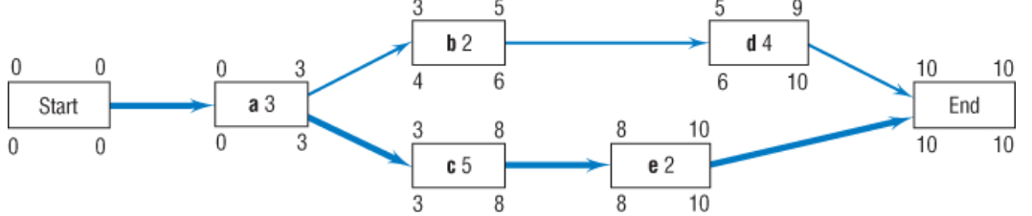

* Assume that the Planned Value is proportionally to the duration of the task. That is, if a task has duration D-days and task PV of X$, then the per day planned expense is X$/D.
* You agreed with your team that you will follow the 0-100% rule for calculating the Earned Value.

1. (1pt) What is the total budget for all tasks to be completed?
2. (8pts) Compute the Project Budget (PV) per day and plot it using Excel. Attach the image of the plot here*
3. (3pts) You are given the Actual Cost (AC) at the end of the days of completing the tasks. Add this to your previous plot and attach the new image*
4. (5pts) Assume that the project progresses very well, exactly per plan. Compute the earned value per day and plot it on the previous graph. Add this new image here*
5. (4pts) Consider the end of Day 8th. Compute
   1. SPI
   2. CPI
   3. CSI
6. (4pts) Embed your spreadsheet here. *No credit if not attached correctly*

**Note \***: *you will get no credit for this question if your calculations are not correct, OR your plot image is not attached.*

**Answers:**

***